**CS825-001, Spring/Summer 2020**

**Assignment 2**

**Submitted to Dr. Xue Dong Yang**

**By**

**Adarsh Koppa Manjunath**

**200397257**

**Problem 1. [25 marks - Image Intensity Transformation, Power-Law Transformation, Gamma Correction] Power-law function for image intensity transformation is defined as 𝑠 = 𝑇(𝑟) = (𝐿 − 1) ( 𝑟/ 𝐿 − 1 ) 𝛾 where L is the number of intensity levels and γ is a positive parameter. The following graph shows shape of s = T(r) for various parameter values.**

**Explain what effects to an image are if (a) γ < 1.0; (b) γ = 1.0; and (c) γ > 1.0, respectively, and why**

**As we saw in the question, there is non-linearity transformation between the original value r and the mapped value s.**

**Solution**-

**1.1)**

When γ<1.0 original dark region of the image will be brightened

When γ=1.0 original image won’t be affected

When γ>1.0 original image will become darker

We Can see this result in the below 2 figures.

1st figure is - Image: 256 x 256 grayscale with γ =0.3, 2) γ=1 and 3) γ=1.8

When γ =0.3, image is brighter, and visible and clearer than original image

When γ =1.0, we don’t see any change when compared to original image

Finally, when γ =1.8, image has become more darker compared to original image.

Similarly we can see the same in Fig 2 as well which is Forest: 452 x 307 grayscale images with γ =0.3, 2) γ=1 and 3) γ=1.8

1.2) 6 images. Fig-1 include 3 images of 256 x 256 grayscale with γ =0.3, 2) γ=1 and 3) γ=1.8 and Fig-2 include 3 images of 256 x 256 grayscale with γ =0.3, 2) γ=1 and 3) γ=1.8. Totally six testing results.

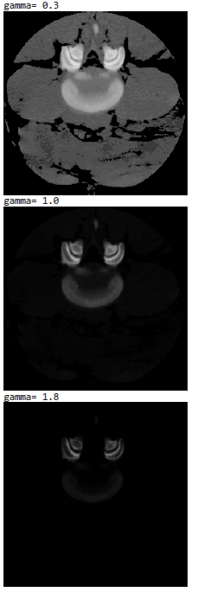

Fig 1- Image: 256 x 256 grayscale with γ =0.3, 2) γ=1 and 3) γ=1.8

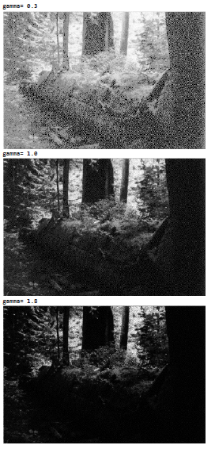

Fig 1- Forest: 452 x 307 grayscale images with γ =0.3, 2) γ=1 and 3) γ=1.8

**Problem 2. [25 marks - Histogram, Cumulative Histogram] Write a complete program that computes and displays the histogram and the cumulative histogram of an input image. Test your program with the two original testing images and the six transformed new images from Problem 1.**

**Solution-**

Below four plots are on **image 256*256 for histogram**. Plot 1 is on original image, and Plot 2, Plot 3, and Plot 4 are on images with gamma=0.3, 1.0 and 1.8 respectively.

Plot 1 - Image-256*256 on histogram

Plot 2- Image 256*256 gamma=0.3 on histogram

Plot 3- image 256*256 with gamma=1.0 on histogram

Plot 4- image 256*256 with gamma=1.8 on histogram

Below four plots are on **image 256*256 for Cumulative Histogram**. Plot 5 is on original image, and Plot 6, Plot 7, and Plot 8 are on images with gamma=0.3, 1.0 and 1.8 respectively.

Plot 5- image 256*256 on cumulative histogram

Plot 6- image 256*256 on cumulative histogram with gamma=0.3

Plot 7- image 256*256 on cumulative histogram with gamma=1.0

Plot 8- image 256*256 on cumulative histogram with gamma=1.8

Below four plots are on **forest** **image 452*307 for Histogram**. Plot 9 is on original image, and Plot 10, Plot 11, and Plot 12 are on images with gamma=0.3, 1.0 and 1.8 respectively.

Plot 9-forest image 452*307 for histogram

Plot 10-forest image 452*307 for histogram with gamma=0.3

Plot 11-forest image 452*307 for histogram with gamma=1.0

Plot 12-forest image 452*307 for histogram with gamma=1.8

Below four plots are on **forest** **image 452*307 for Cumulative Histogram**. Plot 13 is on original image, and Plot 14, Plot 15, and Plot 16 are on images with gamma=0.3, 1.0 and 1.8 respectively.

Plot 13-forest image 452*307 for cumulative histogram

Plot 14-forest image 452*307 for cumulative histogram with gamma=0.3

Plot 15-forest image 452*307 for cumulative histogram with gamma=1.0

Plot 16-forest image 452*307 for cumulative histogram with gamma=1.8

Below 16 images are histogram and cumulative histogram images for image 256*256 and forest image 452*307. These images include original images and images for the gamma values of 0.3, 0.1 and 1.8.

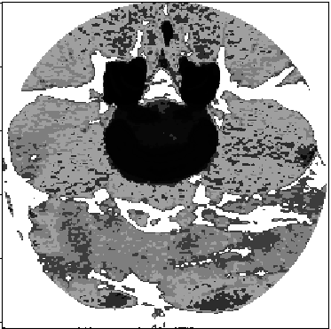

**Fig 3- image 256*256 histogram**

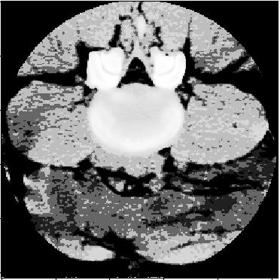

**Fig 4- image 256 *256 Cumulative histogram**

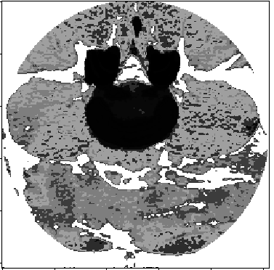

**Fig 5- image 256*256 histogram and gamma= 0.3**

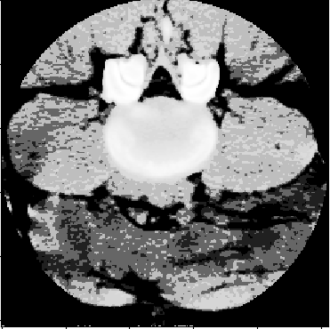

**Fig 6- image 256*256 cumulative histogram gamma= 0.3**

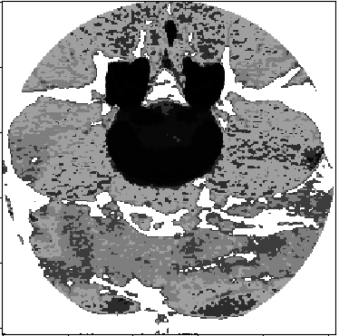

**Fig 7- image 256*256 histogram gamma= 1.0**

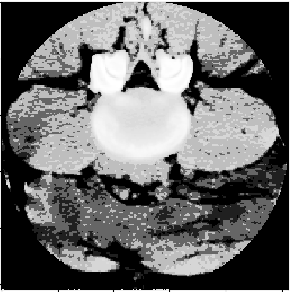

**Fig 8- image 256*256 cumulative histogram gamma= 1.0**

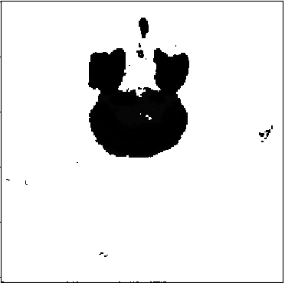

**Fig 9- image 256*256 histogram gamma= 1.8**

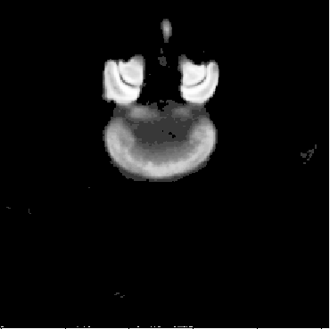

**Fig 10- image 256*256 cumulative histogram gamma= 1.8**

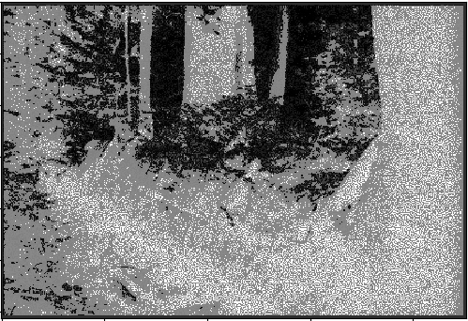

Fig 11-forest image 452*307 histogram

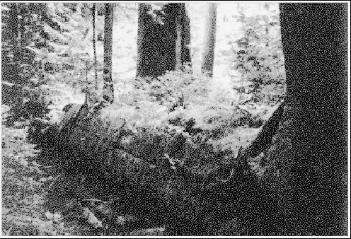

Fig 12-forest image 452*307 cumulative histogram

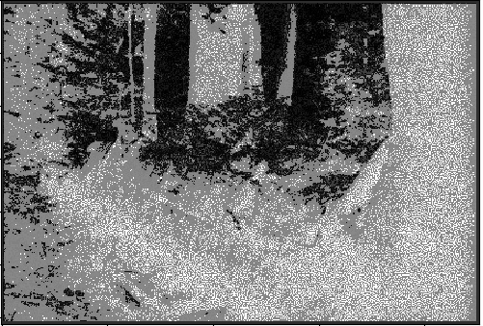

Fig 13-forest image 452*307 histogram gamma=0.3

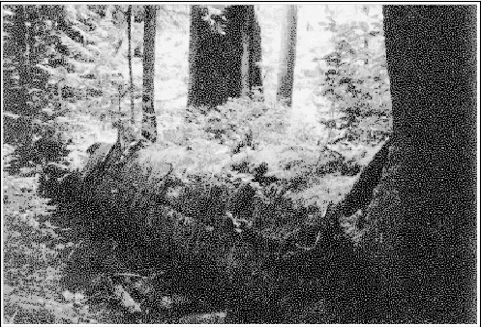

Fig 14-forest image 452*307 cumulative histogram gamma=0.3

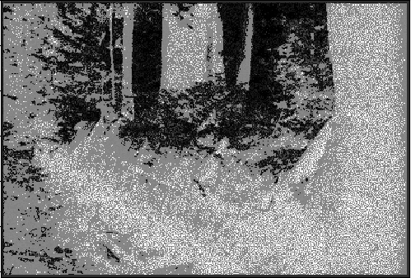

Fig 15-forest image 452*307 histogram gamma=1.0

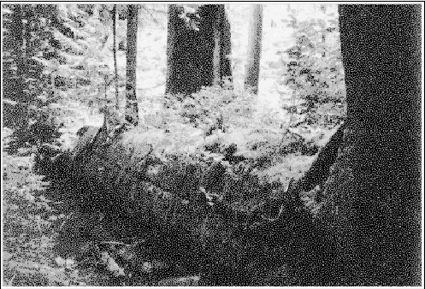

Fig 16-forest image 452*307 cumulative histogram gamma=1.0

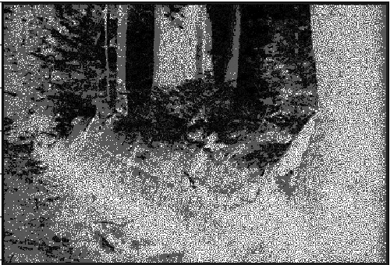

Fig 17-forest image 452*307 histogram gamma=1.8

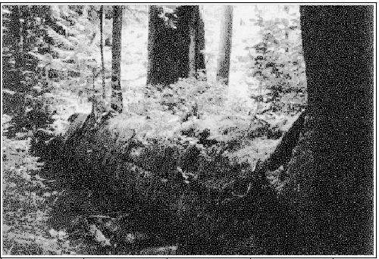

Fig 18-forest image 452*307 cumulative histogram gamma=1.8

**Problem 3. [40 marks - Histogram equalization]**

**1) Write a complete program that implements the traditional histogram equalization algorithm. That is, (a) compute the histogram of an input image (i.e. PDF); (b) compute its cumulative histogram (i.e. CDF); and (c) transform the input image using CDF as the transformation function. Test your program with the two images in Problem 1.**

Transformed image of test image 1 using traditional histogram equalization algorithm

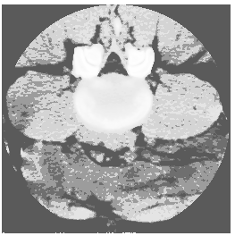

Fig-19 Transformed image of test image 1 using traditional histogram equalization algorithm

Transformed image of test image 2 using traditional histogram equalization algorithm

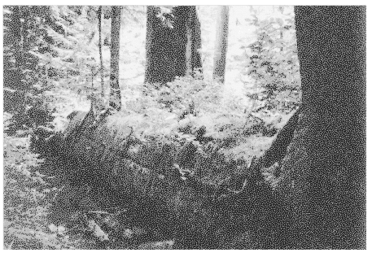

Fig 20- Transformed image of test image 2 using traditional histogram equalization algorithm

**2) Write another complete program that implements my novel divide-and-conquer algorithm for histogram equalization.**

Transformed image of test image 1 using novel divide-and-conquer algorithm for histogram equalization.

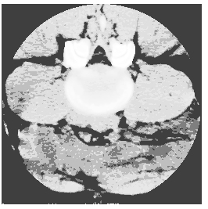

Fig 21- Transformed image of test image 1 using novel divide-and-conquer algorithm for histogram equalization.

Transformed image of test image 2 using novel divide-and-conquer algorithm for histogram equalization.

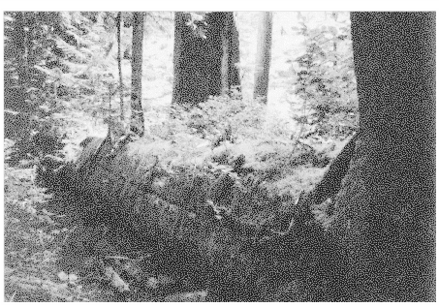

Fig 22- Transformed image of test image 2 using novel divide-and-conquer algorithm for histogram equalization.

**3) Compare the histograms of the result images from 1) and 2) respectively. Briefly discuss your observations.**

After computing cdf in 1st method, we had to scale it, but in case of novel method it will be almost close to scaled cdf and no need of scaling. Only last element was not filled, which was filled later using neighbor value. Same with 2nd image as well. Novel method took lesser time compared to traditional algorithm.

Below 2 images are comparison between novel and traditional algorithm, in novel image, some part of the image seems brighter than traditional method, and also, in novel method, background is a bit darker compared to original method.



**Traditional Method Novel Method**

Below 2 images are comparison between novel and traditional algorithm, in novel image, some part of the image seems brighter than traditional method.



Traditional Method



Novel Method

**4)**

**A)**

**C1 = [150, 80, 120], estimate its hue with calculation details**.

Can be decomposed into 2 parts.

[150,80,120] = [80,80,80] + [70,0,40]

Hue is calculated by liner interpolation

(360*70+240*40)/110 = 316.3636363636364 degrees

**B)**

**Given another color, C2 = [75, 40, 60], estimate its hu**e.

Can be decomposed into 2 parts.

[75,40,60]=[40,40,40]+[35,0,20]

Hue is calculated by liner interpolation

(360*35+240*20)/55= 316.3636363636364 degrees

**C) Are the two hue values approximately same or exactly same?**

Yes, they are exactly same. Its because color values C2 is exactly half of color values of C1.

**D) Do C1 and C2 have approximately same or exactly same saturation?**

C1 saturation= (70+0+40)/(150+80+120)=0.3142

C2 saturation = (35+0+20)/(75+40+60)=0.3142

Yes, C1 and C2 have same saturation, it is because color values of C2 is exactly half of color values of C1.

**E) Are the intensities of C1 and C2 same or different? If they are different, estimate the ratio between the intensities of C1 and C2, and briefly explain your method.**

C1 intensity = (150+80+120)/3 = 116.66

C2 intensity = (75+40+60)/3 = 58.33

C1 and C2 intensities are different

C2 intensity = (C1 intensity) / 2

Intensity is average of the intensities of R, G, and B. C2 intensity of R, G and B is exactly half of C1 intensity of R, G and B

**F) Given another color, C3 = [150, 120, 80], estimate its hue.**

Can be decomposed into 2 parts

[150,120,80]=[80,80,80]+[70,40,0]

Hue is calculated by liner interpolation

(360*70+120*40)/110=272.7272 degrees

**G) Can you compare the intensities between C3 and C1? Briefly explain how**

C1 intensity = (150+80+120)/3 = 116.66

C3 intensity = ((150+120+80)/3)=116.66

Yes, C1 and C3 have same intensities.

Intensity is average of the intensities of R, G, and B. Average of C1 intensity of R, G and B is exactly same as the average of C3 intensity of R, G and B.

**H)The concepts of saturation and intensity are often confused by some people. Briefly explain the difference between the two.**

Saturation is the amount of white light mixed with the hue or we can also say relative purity. Color is considered as purest when it is fully saturated with the saturation value 1.0 and unsaturated color value will be 0.0. The saturation of a color is determined by a combination of light intensity and how much it is distributed across the spectrum of different wavelengths (hue).

Intensity refers to lightness or darkness of a color. Signifies the quantity of light reflected. When it comes to pigments, dark values are called “shades” Light values “tints”.